Date:

EXPERIMENT NO. 4

AIM: Understand and identify Layer-2 functionality.

Exercise-1
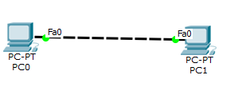
Redraw above diagram which includes IP address and MAC address. Take IP address and MAC address as per your knowledge.

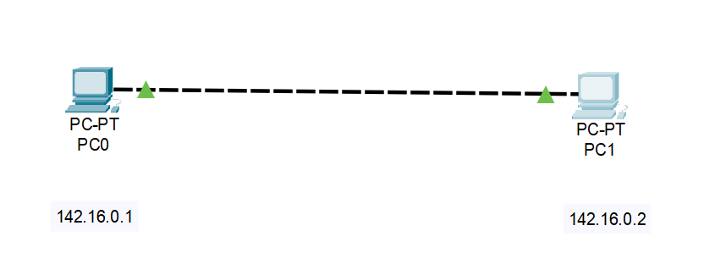

Fill ARP table entry of PC0 after ping
IP address | MAC Address
142.16.0.1 | 00D0.D3C7.654C

Fill ARP table entry of PC1 after ping
IP address | MAC Address
142.16.0.2 | 0001.6418.869E

Exercise-2 :

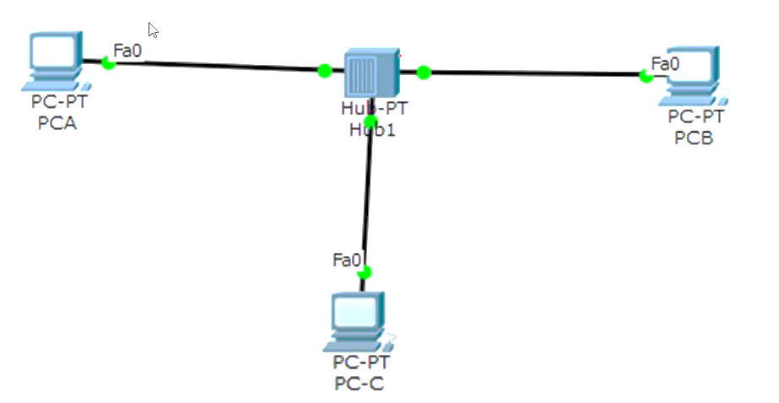
Redraw above diagram which includes IP address and MAC address. Take IP address and MAC address as per your knowledge.

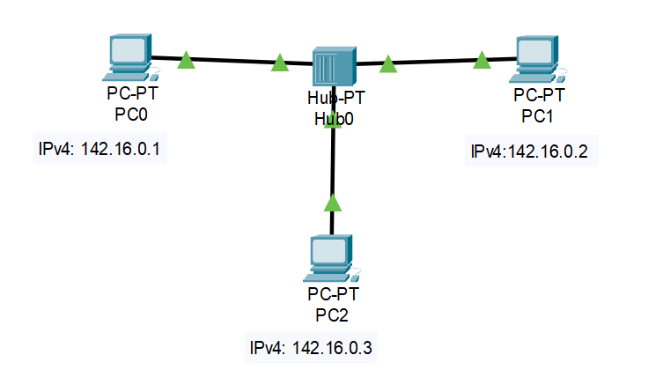

Fill ARP table entry of PCA after Ping

142.16.0.2 | 00D0.BA66.29DE
142.16.0.3 | 0001.4367.78E4

Fill ARP table entry of PCB after Ping
142.16.0.1 | 00E0.F975.8666
142.16.0.3 | 0001.4367.78E4

Fill ARP table entry of PCC after Ping
142.16.0.1 | 00E0.F975.8666
142.16.0.2 | 00D0.BA66.29DE

Fill Switch table entry of Hub0

MAC Address | Ethernet port no
No MAC Address | No Ethernet Port No.

Exercise-3:
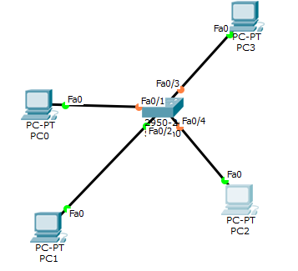
Redraw above diagram which includes IP address and MAC address. Take IP address and MAC address as per your knowledge.

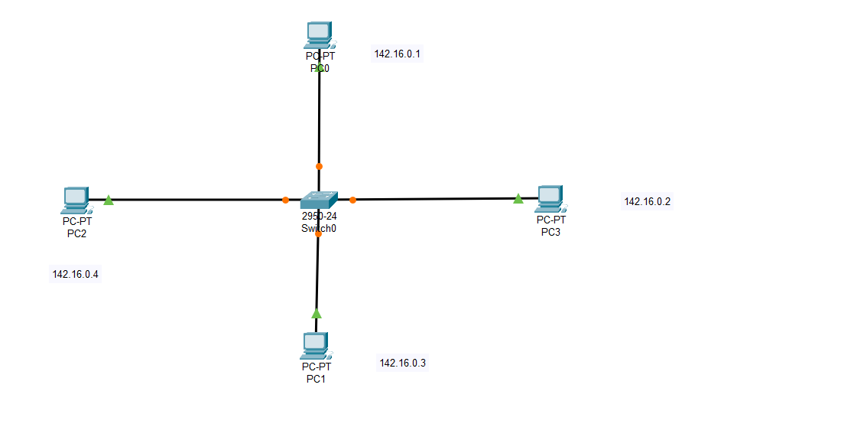

Fill ARP table entry of PC0 after Ping
155.16.0.2 | 00D0.FFA8.E0E8
155.16.0.3 | 0003.E44B.29C9
155.16.0.4 | 0001.6401.8B6E

Fill ARP table entry of PC1 after ping
155.16.0.1 | 000C.CF7A.4B6D
155.16.0.2 | 00D0.FFA8.E0E8
155.16.0.4 | 0001.6401.8B6E

Fill ARP table entry of PC2 after Ping
155.16.0.1 | 000C.CF7A.4B6D
155.16.0.2 | 00D0.FFA8.E0E8
155.16.0.3 | 0003.E44B.29C9

Fill ARP table entry of PC3 after Ping
155.16.0.1 | 000C.CF7A.4B6D
155.16.0.4 | 0001.6401.8B6E
155.16.0.3 | 0003.E44B.29C9

Fill Switch table entry of Switch0 after Ping
0001.6401.8B6E | FastEthernet 0/4
0003.E44B.29C9 | FastEthernet 0/3
000C.CF7A.4B6D | FastEthernet 0/1
00D0.FFA8.E0E8 | FastEthernet 0/2

Exercise-4:
SSSSSS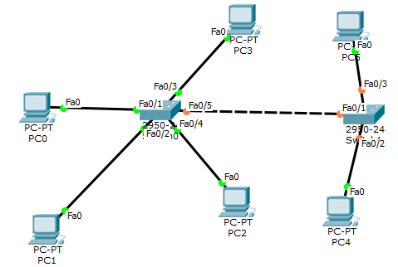
Redraw above diagram which includes IP address and MAC address. Take IP address and MAC address as per your knowledge.

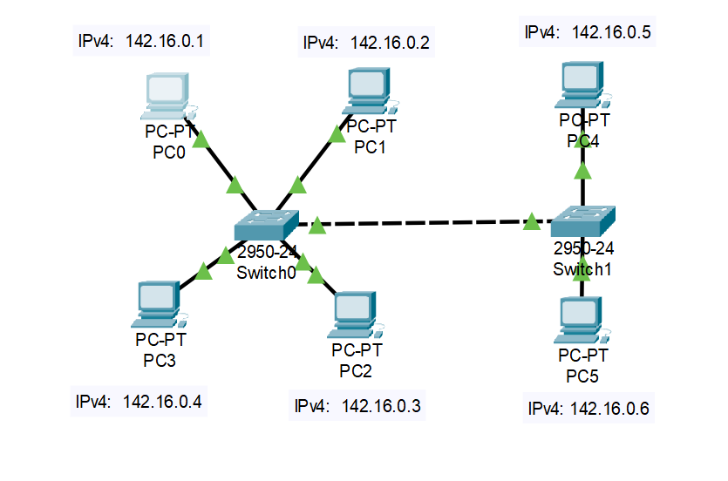

ARP table entry of PC0 after pings

Internet Address | Physical Address
142.16.0.2 | 00D0.976B.DC94
142.16.0.3 | 00D0.9703.AE76
142.16.0.4 | 0001.4292.2E38
142.16.0.5 | 00D0.D361.45CC
142.16.0.6 | 0090.212E.6507

ARP table entry of PC1 after pings
Internet Address | Physical Address
142.16.0.1 | 0005.5E93.05B3
142.16.0.3 | 00D0.9703.AE76
142.16.0.4 | 0001.4292.2E38
142.16.0.5 | 00D0.D361.45CC
142.16.0.6 | 0090.212E.6507

ARP table entry of PC2 after pings
Internet Address | Physical Address
142.16.0.1 | 0005.5E93.05B3
142.16.0.2 | 00D0.976B.DC94
142.16.0.4 | 0001.4292.2E38
142.16.0.5 | 00D0.D361.45CC
142.16.0.6 | 0090.212E.6507

ARP table entry of PC3 after pings
Internet Address | Physical Address
142.16.0.1 | 0005.5E93.05B3
142.16.0.2 | 00D0.976B.DC94
142.16.0.3 | 00D0.9703.AE76
142.16.0.5 | 00D0.D361.45CC
142.16.0.6 | 0090.212E.6507

ARP table entry of PC4 after pings
Internet Address | Physical Address
142.16.0.1 | 0005.5E93.05B3
142.16.0.2 | 00D0.976B.DC94
142.16.0.3 | 00D0.9703.AE76
142.16.0.4 | 0001.4292.2E38
142.16.0.6 | 0090.212E.6507

ARP table entry of PC5 after pings

Internet Address | Physical Address
142.16.0.1 | 0005.5E93.05B3
142.16.0.2 | 00D0.976B.DC94
142.16.0.3 | 00D0.9703.AE76
142.16.0.4 | 0001.4292.2E38
142.16.0.5 | 00D0.D361.45CC

Switch table entry of Switch0
0001.4292.2E38 | FastEthernet 0/2
0005.5E93.05B3 | FastEthernet 0/3
0030.F24D.6501 | FastEthernet 0/1
00D0.976B.DC94 | FastEthernet 0/4
00D0.9703.AE76 | FastEthernet 0/5

Switch table entry of Switch1
00D0.BA7A.7C01 | FastEthernet 0/1
0005.5E93.05B3 | FastEthernet 0/1
0090.212E.6507 | FastEthernet 0/2
00D0.D361.45CC | FastEthernet 0/3

CONCLUSIONS:

Post-Lab Assignment Questions
(Write answers in file pages, do not take print of this page)

Scenario Section

- List out Different network devices and give a small introduction of the same.

- write down difference between HUB and SWITCH.

Exercise 1
- What does ARP table contain?

- Why there is need of ARP table?

- What is topology name of exercise-1?

- What is relation of IP address with MAC address?

- Can we change MAC Address of machine?

- Can we change IP address of machine?

Exercise 2
- What is functionality of Hub?

- Does hub have IP address?

- Does hub have switch (ARP) table?

- What is topology of exercise-2?

Exercise 3
- What is functionality of switch?

- Does switch have IP address?

- Does switch have switch (ARP) table?

- What is topology name of exercise-3?

Exercise 4
- Does both the switch will have identical switching table?

- In Exercise-4, why does PC0 contain IP MAC address of PC4?

- What is topology name of exercise-4?

